Full Paper Title in Title Case (Font: Arial 18 bold)

First Author¹, Second Author² and Third Author³
¹first author affiliation and email
²second author affiliation and email
³third author affiliation and email

ABSTRACT
This file provides a template for writing a paper for 14th International Conference in “Standardization, Protypes and Quality: A Means of Balkan Countries’ collaboration”, September 21 - 22, 2018, Tirana, Albania.
Participants, who wish to present a paper relative to the above topics, should send an abstract (200 -300 words, in Word, Arial 10, full aligned) to the conference secretariat email: bcconference@albanianuniversity.edu.al until April 29, 2018. The submitted abstract should include the name(s) of the author (s), as well as his/her (their) affiliation (including e-mail address). After the notification of acceptance, authors are requested to send also the full paper until June 24, 2018. Full papers will be included in the Conference Proceedings (ISBN publication) after reviewing and accepting.

Key Words: Maximum 4 Key words.

1. INTRODUCTION
It is expected that authors will submit carefully written and proofread material. Spelling and grammatical errors, as well as language usage problems, are not acceptable in the final submission. There is no strict limitation to the number of pages, but it is suggested that the paper length should not exceed 5000 words.
Papers should clearly describe the background of the subject, the authors work, including the methods used, and concluding discussion on the importance of the work. Papers are to be prepared in English. Technical terms should be explained. Abbreviations and acronyms should be written out the first time they are used in the text, even if they have been defined in the abstract. Do not use abbreviations in the title unless they are unavoidable.

2. SUBMITTING THE Paper
The Full paper has to be submitted electronically by e-mail to the following address: bcconference@albanianuniversity.edu.al until June 24, 2018.

3. paper format
The uniform outlook will help the reader to follow the proceedings. This can be obtained most easily if authors use this template file to construct their papers. Please note the following details: this template is an A4 format. All text paragraphs should be single spaced, with first line intended by 10 mm. Double spacing should only be used before and after headings and subheadings as shown in this example. Position and style of headings and subheadings should follow this example. No spaces should be placed between paragraphs. Please do not change any of the above mentioned page, paragraph and font settings.

3.1. Fonts
Papers should use 11 point Arial font. The styles available are bold, italic and underlined.
It is recommended that text in figures is not smaller than 10-point font size.

3.2. Tables and Figures
Figure captions and table headings should be sufficient to explain the figure or table without needing to refer to the text. Figures and tables not cited in the text should not be presented. Styles Heading Table and Caption Figure are available in this template for tables and figures. The following is the example for Table 1.
Table 1 Title of Example Table
Standard Error | 20 Story |  |  |  | 30 Story
 | Uniform | ELF | SRSS | 3 Modes | Uniform | ELF | SRSS | 3 Modes
Displacement | 29.53 | 44.58 | 41.05 | 23.81 | 27.4 | 43.6 | 40.87 | 20.65
Drift | 60.4 | 60.92 | 60.47 | 38.24 | 60.91 | 63.83 | 63.53 | 26.19

Tables and figures should be placed close after their first reference in the text. All figures and tables should be numbered with Arabic numerals. Table headings should be above the tables. Figure captions should be centred below the figures. Minimum figures’ resolution: 150dpi.

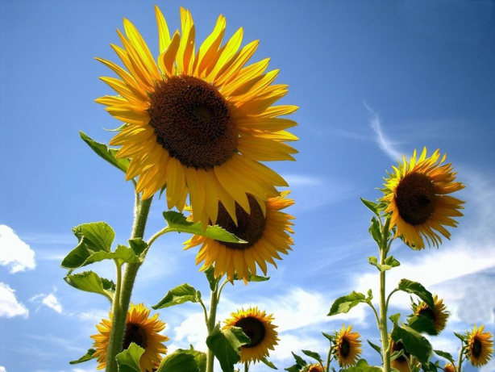
Figure 1: 30 Floor Building’s Drift Ratios Percent

3.3. Equations
Number equations consecutively with equation numbers in parentheses flush with the right margin, as in (1). To make your equations more compact, you may use the solidus (/) and the exp function, etc. Italicize Roman symbols for quantities and variables, but not Greek symbols. Use an en dash (–) rather than a hyphen for a minus sign. Use parentheses to avoid ambiguities in denominators. Punctuate equations with commas or periods when they are part of a sentence, as in

(1)

Symbols in your equation should be defined before the equation appears or immediately following. Cite equations using “(1),” not Eq. (1)” or “equation (1),” except at the beginning of a sentence: “Equation (1) is …”

3.4. References
Number citations consecutively in square brackets [1]. Punctuation follows the bracket [2]. Refer simply to the reference number, as in [3]. Use “Ref. [3]” or Reference [3]” at the beginning of a sentence: “Reference [3] was the first …”
Give all authors’ names; use “et al.” if there are six authors or more. Papers that have not been published, even if they have been submitted for publication, should be cited as “unpublished” [4]. Papers that have been accepted for publication should be cited as “in press” [5]. In a paper title, capitalize the first word and all other words except for conjunctions, prepositions less than seven letters, and prepositional phrases.
For papers published in translated journals, first give the English citation, then the original foreign-language citation [6].

REFERENCES
- G. Eason, B. Noble, and I.N. Sneddon, “On certain integrals of Lipschitz-Hankel type involving products of Bessel functions,” Phil. Trans. Roy. Soc. London, vol. A247, pp. 529-551, April 1955.
- J. Clerk Maxwell, A Treatise on Electricity and Magnetism, 3rd ed., vol. 2. Oxford: Clarendon, 1892, pp.68-73.
- I.S. Jacobs and C.P. Bean, “Fine particles, thin films and exchange anisotropy,” in Magnetism, vol. III, G.T. Rado and H. Suhl, Eds. New York: Academic, 1963, pp. 271-350.
- K. Elissa, “Title of paper if known,” unpublished.
- R. Nicole, “Title of paper with only first word capitalized,” J. Name Stand. Abbrev., in press.
- Y. Yorozu, M. Hirano, K. Oka, and Y. Tagawa, “Electron spectroscopy studies on magneto-optical media and plastic substrate interface,” IEEE Transl. J. Magn. Japan, vol. 2, pp. 740-741, August 1987 [Digests 9th Annual Conf. Magnetics Japan, p. 301, 1982].
- M. Young, The Technical Writer’s Handbook. Mill Valley, CA: University Science, 1989.

